Chem 1A Review

Introduction, Measurement, & Calculations
1. Convert the following (show your work via dimensional analysis):
- 23 mm to m

- 45 L to cL

2. Convert to scientific notation (without using calculator):
- 45000000

- 0.00000687

3. Convert to the decimal (without using calculator):
- 2.3 x 10³

- 6.7 x 10⁻⁷

4. Convert the following (show your work via dimensional analysis)
- 410 s to days

- 56.7 in to cm (given 2.54 cm = 1 inch)

5. Solve the following:
- Given a mass of 67 g and a volume of 45 mL, what is the density?

- Given a density of 56 g/mL and a volume of 23 mL, what is the mass?

Matter & Periodic Table
1. What are the three states of matter and how can you tell them apart?

2. Provide 5 observations that would show a chemical change has occurred.
i.
ii.
iii.
iv.
v.

3. Identify each of the following as an element, compound, heterogeneous, or homogeneous mixture.

- Carbon dioxide

- Air

- Silver

- chocolate chip cookie

4. Classify the following as physical or chemical changes.

- Mothballs gradually vaporizing in a closet

- A piece of rubber stretches when you pull it

- Whole milk curdles when you add vinegar to it

5. Label as extensive or intensive properties:

- Length
- Texture
- Weight
- Color

6. Who wrote the Atomic Theory in 1803?

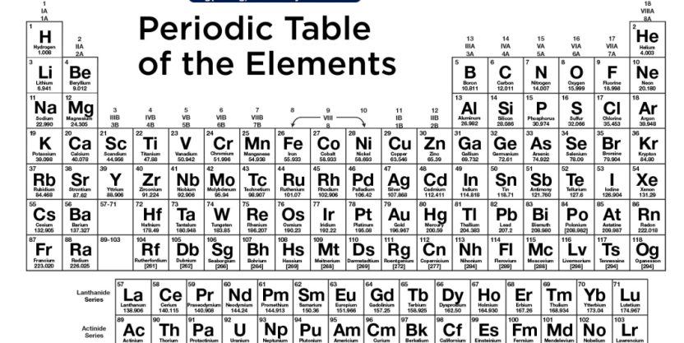
7.
__ Place a in all of the alkali metals
__ Place a in all of the alkaline earth metals
__ Place a in all of the halogens
__ Place a in all of the noble gases
__ Place a in all of the transition metals
__ Shade all 30 of the rare earth metals
__ Draw in the stairstep line
__ Place an * in the box of the 8 semi-metals (metalloids) (not including Ts or Og)
Fill in blanks here:
Metals are located on the ________ side of the stairstep line.
Nonmetals are located on the ________ side of the stairstep line.

8. Using a periodic table, complete the following chart: These could be neutral atoms, isotopes or ions.
Name | Atomic  Number | Atomic  Mass | # protons | # neutrons | # electrons | Overall  Charge
 | 6 | 13 amu |  |  | 6
 |  | 39 amu | 19 |  |  | 0
Bromide ion |  | 80 amu |  |  | 36

9. Describe the periodic table of elements. How are they arranged in a table? What significance is there in the way elements are arranged into vertical groups?

10. List the characteristic physical properties that distinguish metals from nonmetals. Tell what side of the periodic table they both belong to.

11.
Subatomic Particle | Mass (amu) | Charge | Location within Atom

12. Define an isotope. Write the complete atomic symbol for carbon – 12 and carbon – 13.

Nomenclature

Define ionic compounds:

Define covalent (molecular) compounds:

Be able to identify where metals and nonmetals are located on the periodic table.

- Ions: Write the name or formula for the following ions: (use ion chart)
Ion name | Ion formula
Oxide anion
 | F⁻¹
Magnesium ion
 | Na⁺¹
Ammonium ion
 | (SO₄)⁻²

- What are the properties of ionic compounds that tell them apart from molecular compounds?

3. Indicate whether the compound is ionic or molecular. (you will need to look at a periodic table to determine this)
- LiF

- MgI₂

- N₂O₄

4. Identify the type of compound, write the name or chemical formula for each compound: (remember: “2 nonmetals, 2 nonmetals, 2 nonmetals are MO-LEC-U-LAR!”)

Covalent/molecular or Ionic | Name of compound | Chemical Formula
 | Carbon dioxide
 |  | S₄N₂
 | Sulfur difluoride
 |  | ICl₅
 | Tetraboron hexahydride
 |  | CaCl₂
 | Cesium phosphide
 |  | Al₂O₃
 | Zinc oxide
 |  | CuO
 | Ammonium chloride
 | Iron III sulfide

Chemical Reactions
1. Match the type of reaction with the phrase that best describes it.

_____a) Combustion I) oxygen and a substance react
_____b) Decomposition ii) a single reactant
_____c) Synthesis/Combination iii) a single product

2. Balance the following equations AND give type of reaction

Type:__________ ____KClO₃ → ____KClO₄ + ____KCl

Type:__________ ____C₃H₈ + ____O₂ → ____CO₂ + ____H₂O

Type:__________ ____Al + ____ O₂ → ____ Al₂O₃

3.

- Word equation: dihydrogen monoxide → hydrogen + oxygen

Balanced chemical equation:

    - Magnesium combines with oxygen to produce magnesium oxide

Reaction type____________________________

Word equation:

Balanced chemical equation:

    - Carbon tetrahydride burns in oxygen to produce carbon dioxide and water

Reaction type____________________________

Word equation:

Balanced chemical equation:
4. Find the molar mass of the following: (round all masses to two decimal places). Units on molar mass are g/mol.
- KI

- Mg(OH)₂

5. How many molecules are in 3.0 moles of SO₂?

6. Calculate the number of moles in 32.0 g of CH₄ (hint: must find molar mass of CH₄).

7. How many hydrogen atoms are there in 5 molecules of H₂O?
Ie: 1 molecule = 2 H atoms (use dimensional analysis)

8. a) Using the balanced chemical equation, determine how many moles of water are formed if we used 6.0 moles of hydrogen gas. Show your work via dimensional analysis to get your units to cancel. 2 H₂ + O₂ → 2 H₂O

b) how many moles of water are formed if we used 6.0 moles of oxygen gas?
2 H₂ + O₂ → 2 H₂O

Using the sandwich analogy below, answer the following questions.

Recipe to make 1 sandwich: 2 Bd + 4 Hm + 1 Ch + 1 L → 1 Sw

Bd = bread slice
Hm = ham
Ch = cheese slice
L = lettuce
Sw = sandwich (product)

If you had 14 Bd, 32 Hm, 5 Ch, and 9 L how many Sw can you make?

What limited you from making more Sw? (this is your limiting reactant)

What did you have leftover? (these are your excess reactants)

